Application Landing Page (login credential: admin/Welcome@01 )

1. Login button disabled

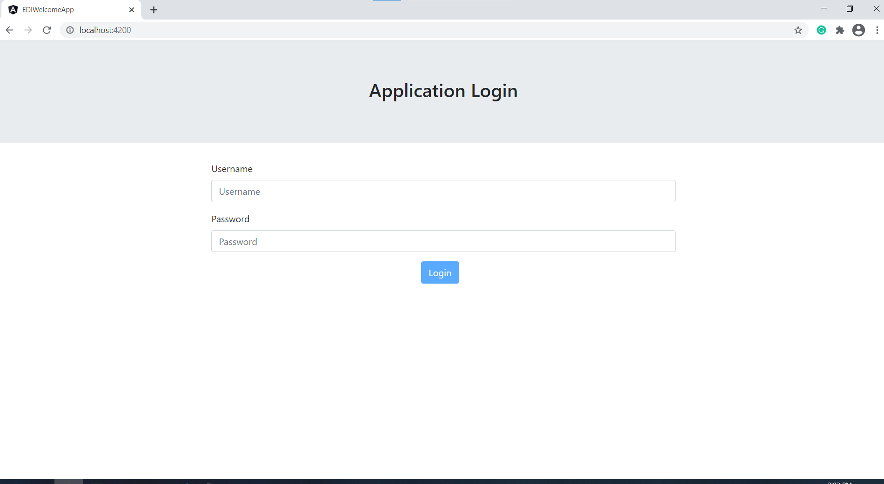

1. Username required validation

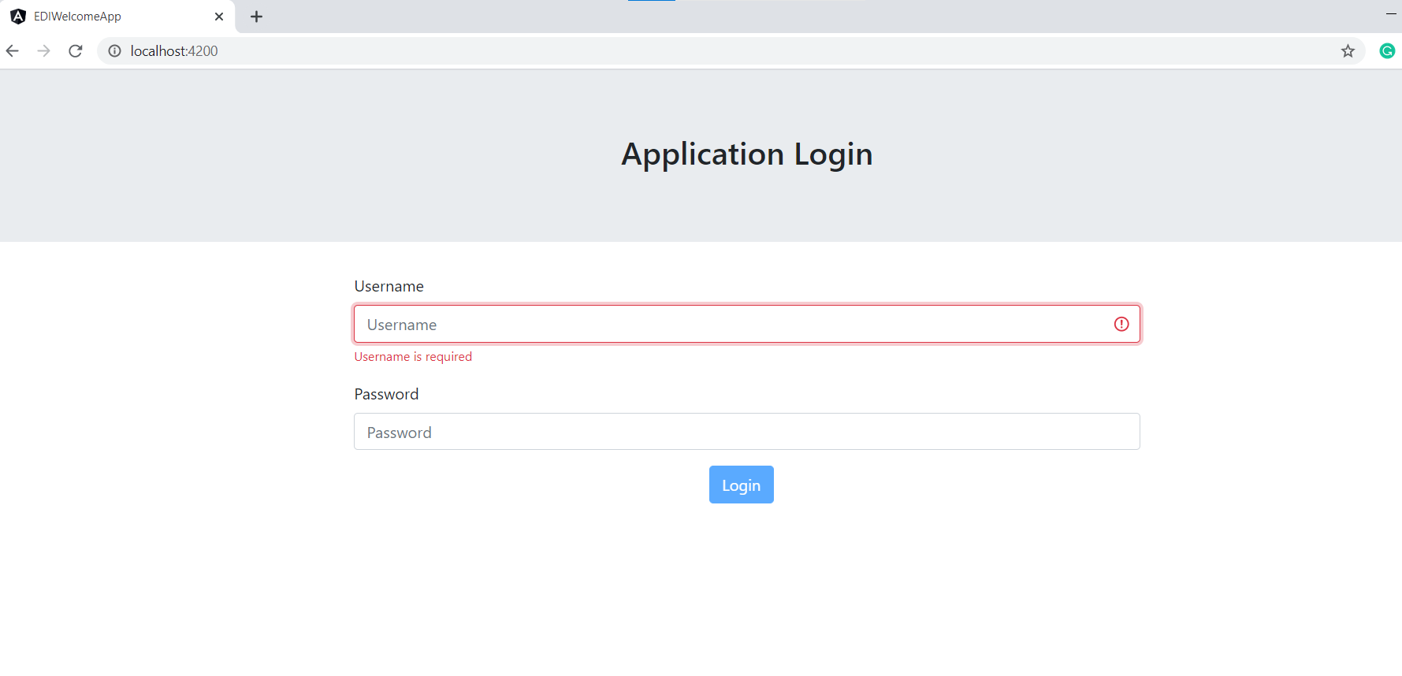

1. Username length validation

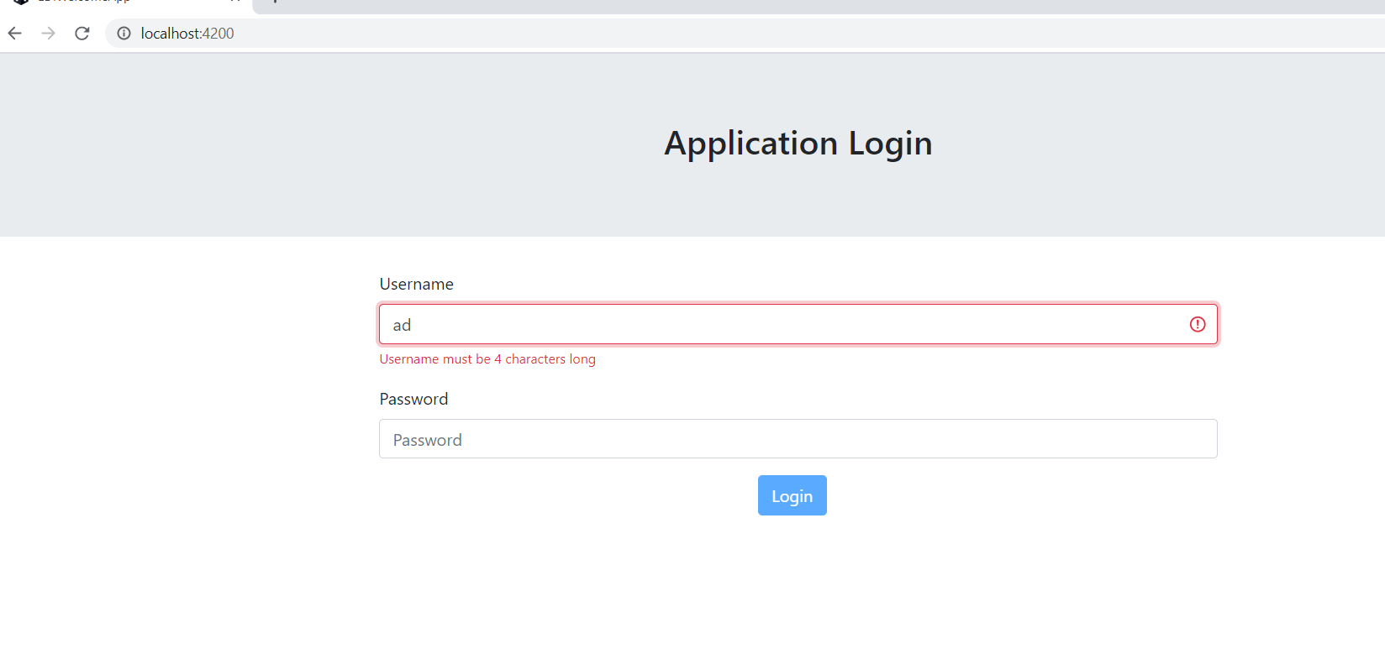

1. Password length validation

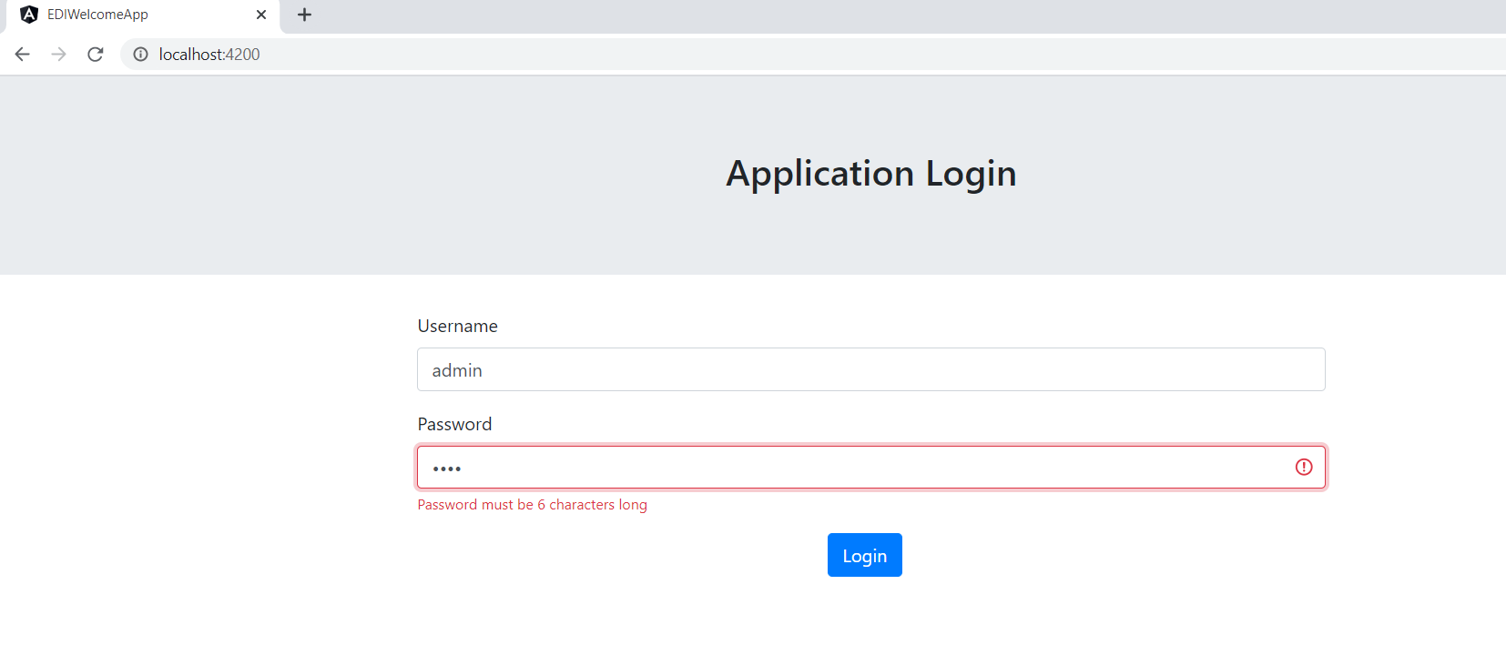

1. Home screen

